# Initial report and EDA for Capstone Assignment 20.1

Chang Liu

I used ML algorithms to fit past stock price data. I analyzed stock data of related companies in the supply chain, including Apple, Microsoft, Intel, and Applied Materials. I also started to implement various hypothetical trading strategies to evaluate stock trading gains.

The ML models used include:

* LSTM RNN analysis of Apple stock price
* ARIMA time series analysis of Apple stock price
* Decision tree model of daily movement (up and down)
* Implemented random walk strategy for stock trading strategy with 4.3% return rate

Raw data is obtained from yahoo finance database.

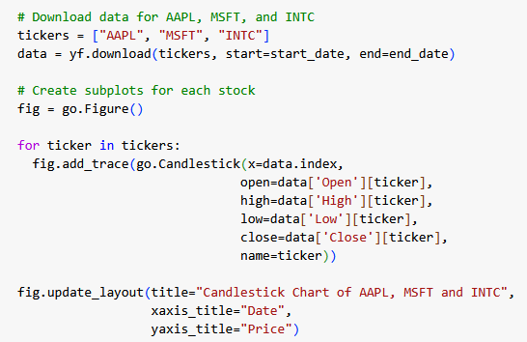 Code for reading financial data.

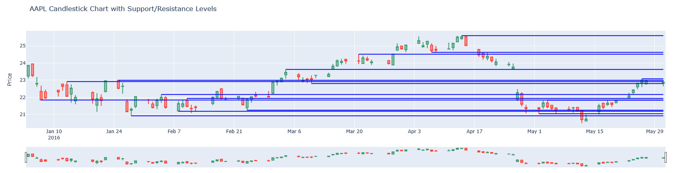

Example of Apple stock and daily support levels.

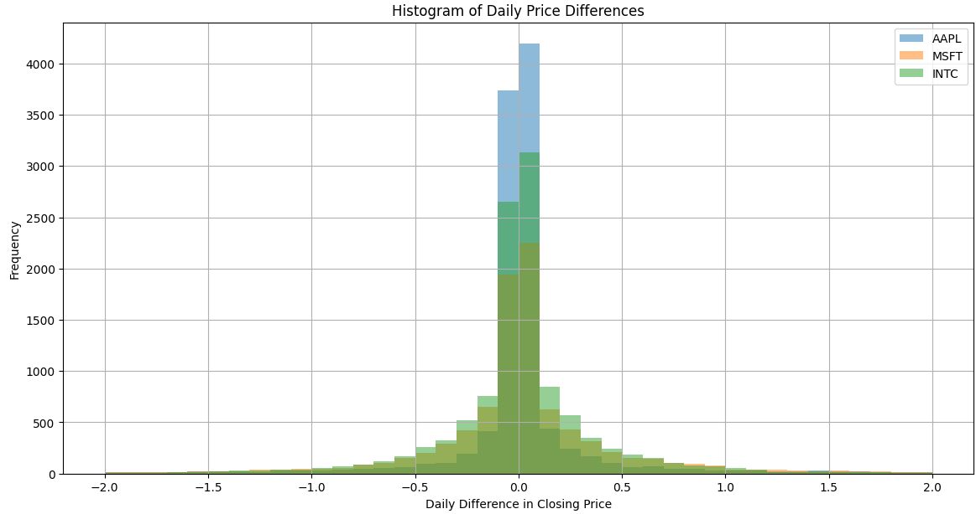

A histogram of daily changes of three stocks. The distribution shows volatility.

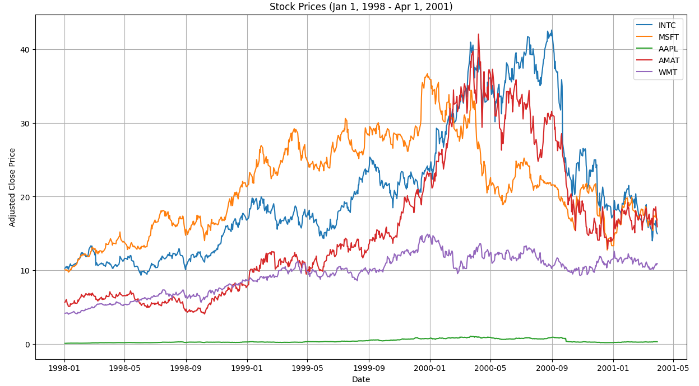

Stock price distribution of five stocks in supply chain – Intl, Applied Materials, Apple, Micosoft and Walmart (retailer).

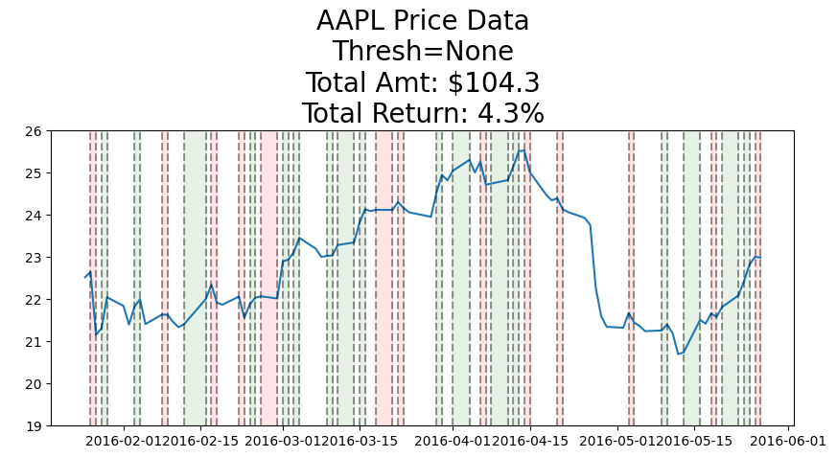

Stock return on hypothetical buy and sell decisions. A return of 4.3% result from a random walk approach based on present-day movement.

The exploration continues …